COURIER MANAGEMENT SYSTEM
Salesforce Activity Documentation

NAME : Bethani L
TOPIC : COURIER MANAGEMENT SYSTEM
NM ID: B51E9D6D50500E5A81A4095A6F78621C

1. SALESFORCE ACCOUNT

Definition
Salesforce is a cloud-based platform used to build and manage business applications. A Developer Edition
account provides an environment for creating and testing the Courier Management System.

Activity 1: Create Developer Account
- Open the Salesforce Developer registration page.
- Enter the required registration details.
- Choose a unique username.
- Accept the required terms.
- Submit the registration form.
- Verify the account from the activation email.
Result: The Salesforce Developer Edition account is created and verified.

1. SALESFORCE ACCOUNT – ACCOUNT ACTIVATION

Definition
Account activation completes the verification and sign-in process so that the Salesforce organization can be
configured.

Activity 2: Account Activation
- Open the activation email.
- Verify the account.
- Set the password if prompted.
- Log in to the Developer Edition org.
- Confirm that the Salesforce Home page is displayed.
- Open Setup when configuration is required.
Result: The Developer Edition organization is ready for project configuration.

2. OBJECTS

Definition
A Salesforce object stores a specific type of business information. Custom objects are used for project-specific data.

Custom Objects Used
No. Object Purpose
- Customer__c Stores customer details.
- Shipment__c Stores shipment information.
- Delivery_Agent__c Stores delivery agent details.
- Branch__c Stores branch information.
- Delivery_Update__c Stores delivery status updates.
- Invoice__c Stores invoice information.

General Activity: Create a Custom Object
- Open Setup.
- Go to Object Manager.
- Click Create and select Custom Object.
- Enter the Label and Plural Label.
- Confirm the object/API name.
- Enable the required project options such as Reports, Activities or Field History.
- Set Deployment Status to Deployed.
- Click Save.

2. OBJECTS – CUSTOMER & SHIPMENT

Activity 1: Create Customer Object
- Open Setup → Object Manager → Create → Custom Object.
- Set Label as Customer and Plural Label as Customers.
- Confirm the Customer__c API name.
- Enable the required project options.
- Set Deployment Status to Deployed.
- Click Save.

Activity 2: Create Shipment Object
- Open Setup → Object Manager → Create → Custom Object.
- Set Label as Shipment and Plural Label as Shipments.
- Confirm the Shipment__c API name.
- Enable the required project options.
- Set Deployment Status to Deployed.
- Click Save.
Result: Customer__c and Shipment__c are created.

2. OBJECTS – DELIVERY AGENT & BRANCH

Activity 3: Create Delivery Agent Object
- Open Setup → Object Manager → Create → Custom Object.
- Set Label as Delivery Agent and Plural Label as Delivery Agents.
- Confirm the Delivery_Agent__c API name.
- Enable the required project options.
- Set Deployment Status to Deployed.
- Click Save.

Activity 4: Create Branch Object
- Open Setup → Object Manager → Create → Custom Object.
- Set Label as Branch and Plural Label as Branches.
- Confirm the Branch__c API name.
- Enable the required project options.
- Set Deployment Status to Deployed.
- Click Save.

2. OBJECTS – DELIVERY UPDATE & INVOICE

Activity 5: Create Delivery Update Object
- Open Setup → Object Manager → Create → Custom Object.
- Set Label as Delivery Update and Plural Label as Delivery Updates.
- Confirm the Delivery_Update__c API name.
- Enable the required project options.
- Set Deployment Status to Deployed.
- Click Save.

Activity 6: Create Invoice Object
- Open Setup → Object Manager → Create → Custom Object.
- Set Label as Invoice and Plural Label as Invoices.
- Confirm the Invoice__c API name.
- Enable the required project options.
- Set Deployment Status to Deployed.
- Click Save.

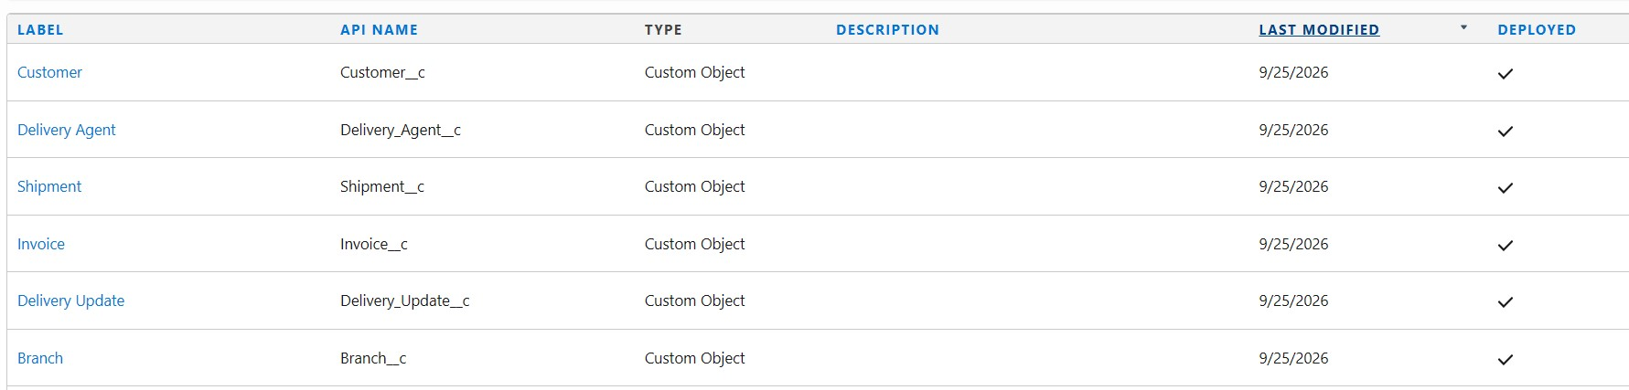

3. TABS
Definition
A tab provides a user interface entry point for opening an object and viewing its records.

Activity: Create Custom Object Tabs
- Open Setup and search for Tabs.
- Open Custom Object Tabs.
- Click New Custom Object Tab.
- Select the required object.
- Choose the tab style.
- Save the tab.
- Repeat the process for the required custom objects.
- Verify the tabs in the application navigation.

Required Navigation Items
- Customers
- Shipments
- Delivery Agents
- Branches
- Delivery Updates
- Invoices
- Reports
- Dashboards
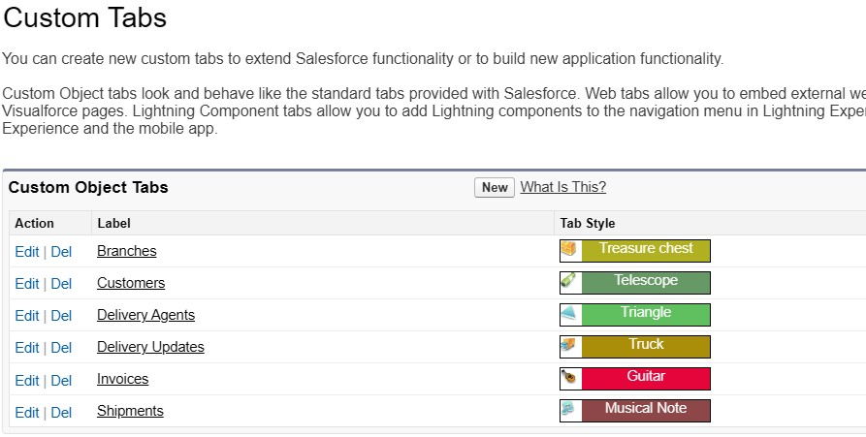

4. FIELDS & RELATIONSHIPS
Definition
Fields store individual values in an object. Relationships connect records from different objects.

Activity: Create a Field
- Open Setup → Object Manager.
- Select the required object.
- Open Fields & Relationships.
- Click New.
- Select the field type.
- Enter the field label and properties.
- Set field-level security and other required options.
- Add the field to the required page layout.
- Click Save.

Activity: Create a Relationship
- Open the child object.
- Open Fields & Relationships and click New.
- Select Lookup Relationship or Master-Detail Relationship as required.
- Select the related object.
- Enter the relationship label.
- Configure visibility and page layout options.
- Click Save and verify the related list.

4. FIELDS – CUSTOMER Activity: Create Customer Fields
Field | Type
Email__c | Email
Phone__c | Phone
Address__c | Text Area
Customer_Type__c | Picklist
City__c | Text
State__c | Text
Pincode__c | Text
Is_Active__c | Checkbox
- Open Object Manager → Customer__c.
- Open Fields & Relationships.
- Click New.
- Select the required field type.
- Enter the field label and field properties.
- Set field-level security as required.
- Add the field to the page layout.
- Click Save.

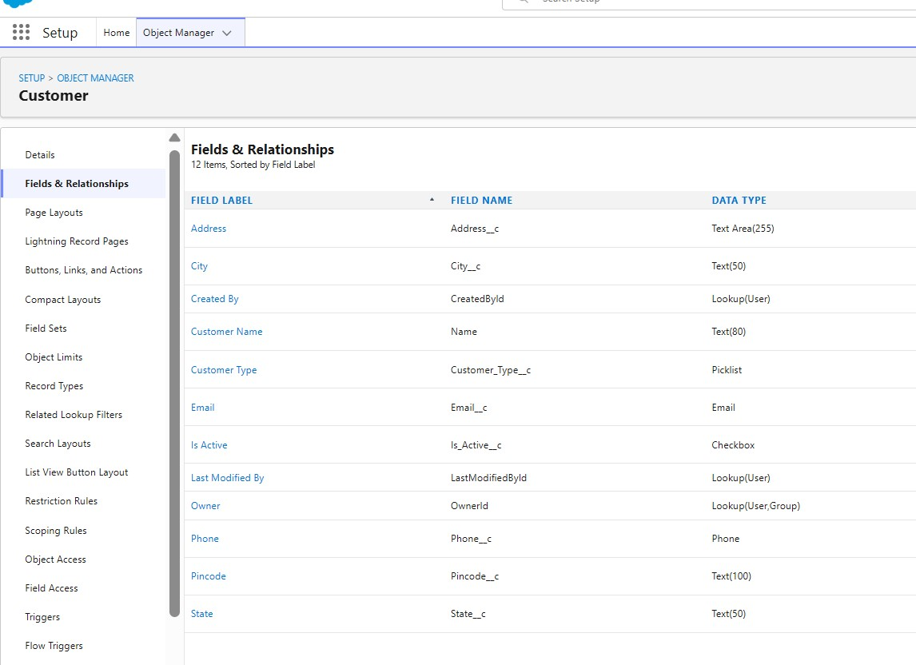
Result: The required Customer fields are available.

4. FIELDS – SHIPMENT Activity: Create Shipment Fields
Field | Type
Customer__c | Lookup
Source_Address__c | Text Area
Destination_Address__c | Text Area
Weight__c | Number
Price__c | Currency
Status__c | Picklist
Expected_Date__c | Date
Assigned_Agent__c | Lookup
Shipment_Type__c | Picklist
- Open Object Manager → Shipment__c.
- Open Fields & Relationships.
- Create each required field with its corresponding type.
- For lookup fields, select the related object.
- For picklist fields, enter the required values.
- Set field-level security and page layout settings.
- Save each field.
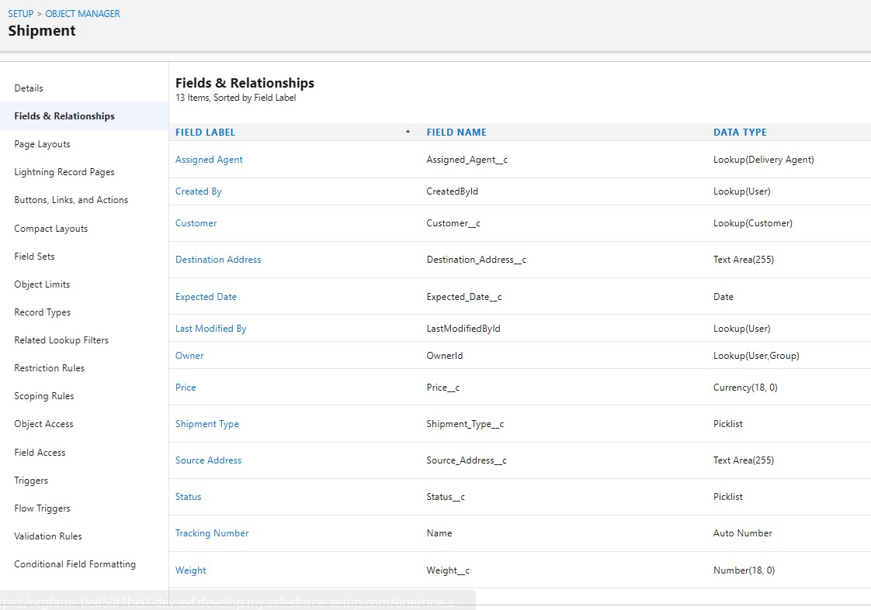
Result: The required Shipment fields are created.

4. FIELDS – DELIVERY AGENT & BRANCH

Activity: Create Delivery Agent Fields
- Email__c – Email
- Phone__c – Phone
- Branch__c – Lookup
- Status__c – Picklist
- Joining_Date__c – Date

Activity: Create Branch Fields
- Branch_Code__c – Text
- City__c – Text
- State__c – Text
- Manager_Name__c – Text
- Open the required object in Object Manager.
- Open Fields & Relationships → New.
- Select the field type.
- Enter the field label and properties.
- Configure lookup/picklist settings where required.
- Set security and layout settings.
- Click Save.

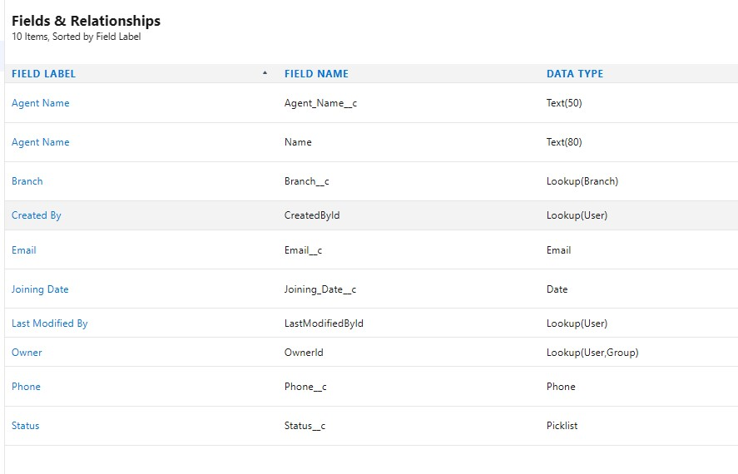
Result: Delivery Agent and Branch fields are created.

4. FIELDS – DELIVERY UPDATE & INVOICE

Activity: Create Delivery Update Fields
- Shipment__c – Master-Detail
- Status__c – Picklist
- Update_Date__c – Date/Time
- Remarks__c – Text

Activity: Create Invoice Fields
- Shipment__c – Lookup
- Amount__c – Currency
- Invoice_Date__c – Date
- Payment_Status__c – Picklist
- Open Object Manager → required object.
- Open Fields & Relationships → New.
- Select the required field type.
- Enter the label and properties.
- Configure relationship fields with the related object.
- Set security and page layout settings.
- Click Save.
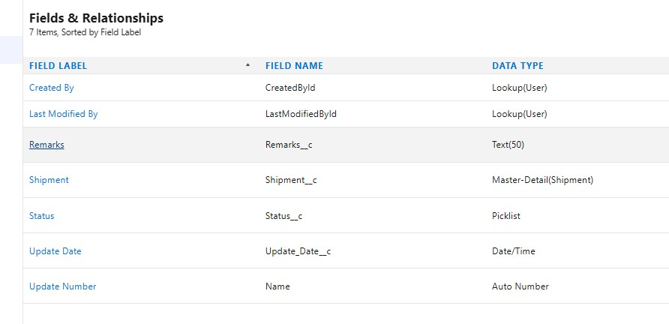
Result: The required Delivery Update and Invoice fields are created.

5. VALIDATION RULES
Definition
A validation rule prevents a record from being saved when the entered data does not satisfy the specified formula.

Activity: Create a Validation Rule
- Open Object Manager → required object.
- Open Validation Rules.
- Click New.
- Enter the rule name.
- Enter the formula.
- Enter the error message.
- Choose the error display location.
- Click Check Syntax.
- Click Save.

Validation Rules Used
- Customer Email – Email must not be blank.
- Customer Phone – Phone length must be valid.
- Customer Pincode – Pincode length must be valid.
- Shipment Weight – Weight must be greater than zero.
- Shipment Price – Price must be greater than zero.
- Expected Date – Prevent invalid past date.
- Delivery Agent Email – Check email format indicator.
- Branch Code – Branch code is required.
- Delivery Update – Delayed status requires remarks.

5. VALIDATION RULE – DELIVERY UPDATE
Activity: Remarks Required If Status is Delayed
Purpose: Require remarks whenever a Delivery Update is saved with the status Delayed.

Step-by-Step Process
- Open Setup → Object Manager → Delivery_Update__c.
- Open Validation Rules.
- Click New.
- Enter Rule Name: Remarks_Required_For_Delay.
- Enter the formula: AND(ISPICKVAL(Status__c,"Delayed"), ISBLANK(Remarks__c)).
- Enter the error message: Remarks are required when status is Delayed.
- Set the error location to the Remarks field.
- Click Check Syntax.
- Click Save.

Formula
AND(ISPICKVAL(Status__c,"Delayed"), ISBLANK(Remarks__c))

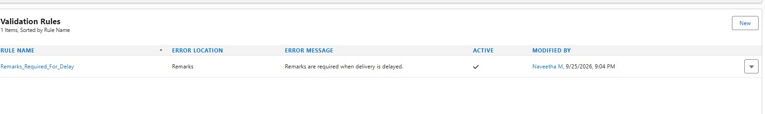

Result: The record cannot be saved as Delayed without remarks.

6. PAGE LAYOUTS

Definition
Page layouts control the fields and sections shown on a Salesforce record page and organize the information for users.

General Activity: Edit a Page Layout
- Open Setup → Object Manager → required object.
- Click Page Layouts.
- Open the required layout.
- Create or arrange sections.
- Drag fields into the appropriate sections.
- Arrange fields logically.
- Click Save.

Project Layouts
- Customer – Customer Information; Address Details
- Shipment – Shipment Details; Address Information; Delivery Information
- Delivery Agent – Agent Details; Additional Information
- Branch – Branch Information
- Delivery Update – Update Information
- Invoice – Invoice Details

6. PAGE LAYOUT – CUSTOMER & SHIPMENT

Activity 1: Customer Layout
- Customer Information: Customer Name, Customer Type, Email, Phone, Is Active
- Address Details: Address, City, State, Pincode

Steps
- Setup → Object Manager → Customer__c.
- Click Page Layouts.
- Open the default Customer Layout.
- Add/arrange the sections.
- Drag the required fields into the sections.
- Click Save.

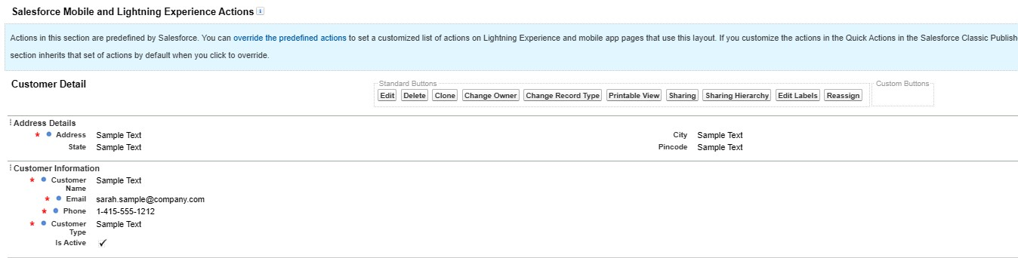

Activity 2: Shipment Layout
- Shipment Details: Tracking Number, Customer, Shipment Type, Weight, Price, Status
- Address Information: Source Address, Destination Address
- Delivery Information: Expected Date, Assigned Agent

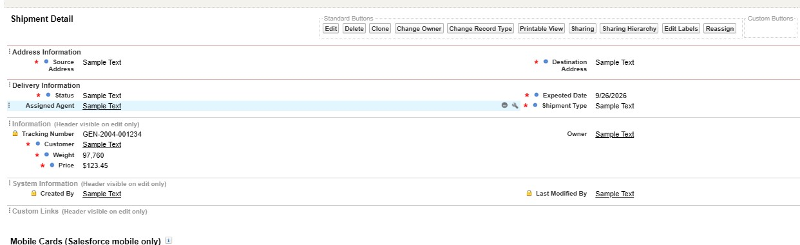

Result: Customer and Shipment layouts are arranged.

6. PAGE LAYOUT – DELIVERY AGENT & BRANCH

Activity 3: Delivery Agent Layout
- Agent Details: Agent Name, Email, Phone, Branch, Status, Joining Date
- Additional Information: Related Shipments, Related Delivery Updates

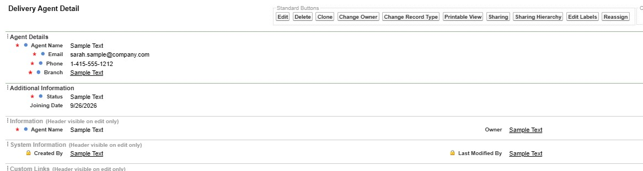

Activity 4: Branch Layout
- Branch Information: Branch Name, Branch Code, City, State, Manager Name
- Open Setup → Object Manager → required object.
- Click Page Layouts.
- Open the default layout.
- Arrange the fields into the required sections.
- Click Save.

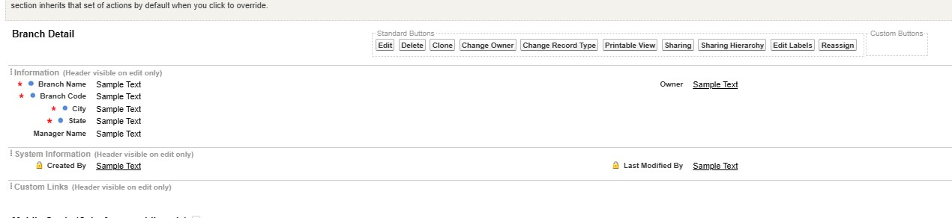

Result: Delivery Agent and Branch layouts are arranged.

6. PAGE LAYOUT – DELIVERY UPDATE & INVOICE

Activity 5: Delivery Update Layout
• Update Information: Update Number, Shipment, Status, Update Date, Remarks

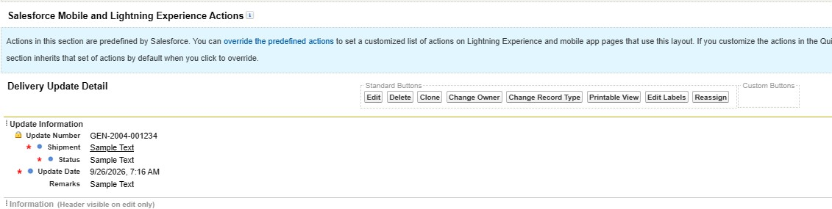

Activity 6: Invoice Layout
- Invoice Details: Invoice Number, Shipment, Amount, Invoice Date, Payment Status
- Open Setup → Object Manager → required object.
- Click Page Layouts.
- Open the default layout.
- Arrange the required fields and sections.
- Click Save.

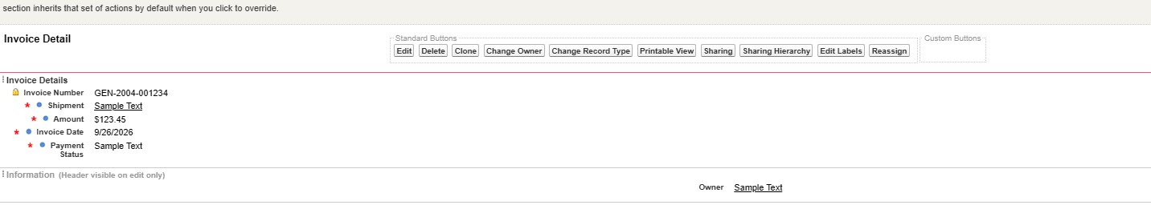

Result: Delivery Update and Invoice layouts are arranged.

7. FLOW

Definition
A Salesforce Flow automates business processes, collects or updates data, and performs actions without requiring manual record updates.

Activity: Auto-Update Shipment Status When Delivery Update is Created
Scenario: Whenever a Delivery_Update__c record is created, automatically update the related Shipment__c Status__c with the latest status from the Delivery Update.

Part 1 – Create the Record-Triggered Flow
- Click the Gear Icon → Setup.
- In Quick Find, type Flows.
- Click Flows.
- Click New Flow.
- Select Record-Triggered Flow.
- Click Create.
- 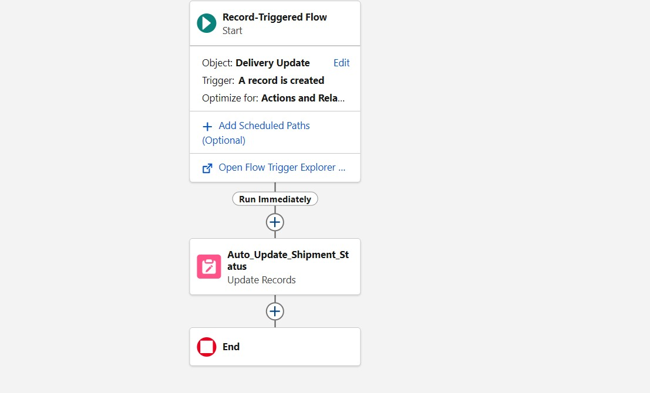

7. FLOW – START CONFIGURATION

Step 2: Configure the Start
- On the Start panel, select Object: Delivery_Update__c.
- Under Trigger the Flow When, select A record is created.
- Under Condition Requirements, choose None.
- Under Optimize the Flow For, select Actions and Related Records.
- Click Done.

Expected Configuration
- Object: Delivery_Update__c
- Trigger: A record is created
- Condition Requirements: None
- Optimize for: Actions and Related Records

7. FLOW – UPDATE RELATED SHIPMENT

Part 2: Add Update Records
- Click the + icon under the Start element.
- Select Update Records.
- Set Label: Update_Shipment_Status.
- Select Specify conditions to identify records.
- Set Object: Shipment__c.
- Set Field: Id.
- Set Operator: Equals.
- Set Value: {!$Record.Shipment__c}.
- Set Shipment Status__c = {!$Record.Status__c}.
- Click Done.

7. FLOW – SAVE & ACTIVATE

Part 3: Save and Activate
- Click Save in the top-right corner.
- Enter Flow Label: Auto_Update_Shipment_Status.
- Allow the API Name to auto-fill.
- Click Save.
- Click Activate.
- Confirm that the Flow status shows Active.

Final Flow Logic
Delivery_Update__c created → find related Shipment__c using Shipment__c lookup → copy Status__c from Delivery Update to Shipment.

8. LIGHTNING APP
Definition
A Salesforce app is a group of tabs that work together as a unit.

Activity: Create Courier Management System App
- From Setup, search for App Manager and open it.
- Click New Lightning App.
- Enter App Name: Courier Management System.
- Upload an image or icon if required, then click Next.
- Under App Options, leave the required/default selections and click Next.
- Under Utility Items, continue as required and click Next.
- Move the required items from Available Items to Selected Items.
- Click Next.
- Select the required profiles.
- Click Save & Finish.

Selected Items
- Customer
- Shipment
- Delivery Agent
- Branch
- Delivery Update
- Invoice
- Reports
- Dashboards

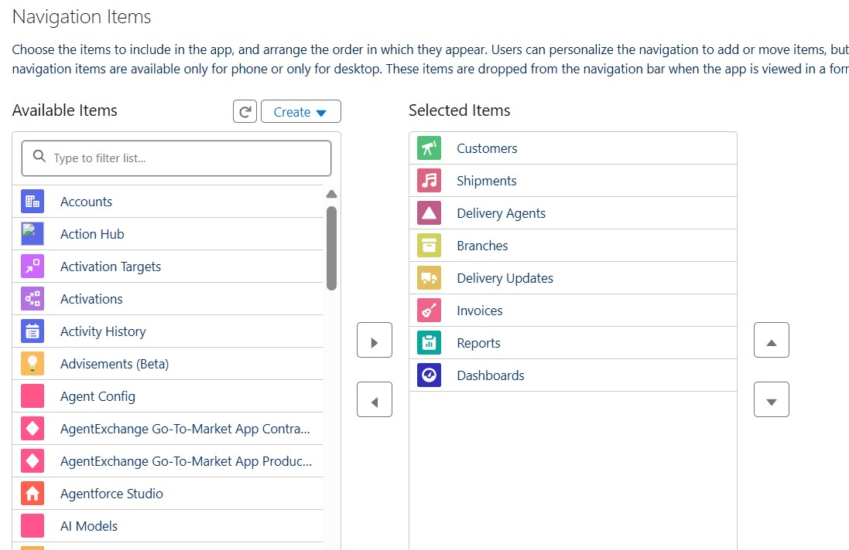

Result: The Courier Management System Lightning App is creatd.

9. PROFILES
Definition
A profile is a collection of settings and permissions that controls what a Salesforce user can access and perform.

Activity 1: Create Courier Admin Profile
- From Setup, enter Profiles in Quick Find.
- Click Profiles.
- Click New Profile.
- Select Existing Profile: System Administrator.
- Enter Profile Name: Courier Admin.
- Click Save.

Activity 2: Create Branch Manager Profile
- Open Profiles and click New Profile.
- Select Existing Profile: Standard Platform User.
- Enter Profile Name: Branch Manager.
- Click Save.
- Click Edit on the Branch Manager profile.

9. PROFILES – BRANCH MANAGER

Activity: Configure Branch Manager
- Set the default app to Courier Management System App.
- Set the required tabs as Default On or Visible: Customers, Shipments, Delivery Agents, Branches, Delivery Updates, Invoices, Reports and Dashboards.
- Scroll to Custom Object Permissions.
- Set Customer__c: Create, Read, Edit.
- Set Shipment__c: Create, Read, Edit.
- Set Delivery_Agent__c: Read, Edit.
- Set Branch__c: Read, Edit.
- Set Delivery_Update__c: Create, Read, Edit.
- Set Invoice__c: Read.
- Under Session Settings, set Session Timeout to 2 Hours of Inactivity.
- Under Password Policies, set User passwords expire in: Never Expires.
- Set Minimum Password Length: 8.
- Click Save.

9. PROFILES – DELIVERY AGENT & CUSTOMER SUPPORT

Activity 3: Create Delivery Agent Profile
- Setup → Profiles → New Profile.
- Existing Profile: Standard Platform User.
- Profile Name: Delivery Agent.
- Set default app: Courier Management System.
- Visible tabs: Shipments, Delivery Updates.
- Shipment__c: Read, Edit.
- Delivery_Update__c: Create, Read, Edit.
- Customer__c: Read.
- Invoice__c: Read.
- Do not grant Branch editing or delete permissions.
- Save.

Activity 4: Create Customer Support Profile
- Setup → Profiles → New Profile.
- Base Profile: Standard User.
- Profile Name: Customer Support.
- Visible tabs: Customers, Shipments, Delivery Updates.
- Customer__c: Read, Edit.
- Shipment__c: Read, Edit.
- Delivery_Update__c: Read.
- Invoice__c: Read.
- Set Session Timeout to 2 Hours and password length to 8.
- Save.
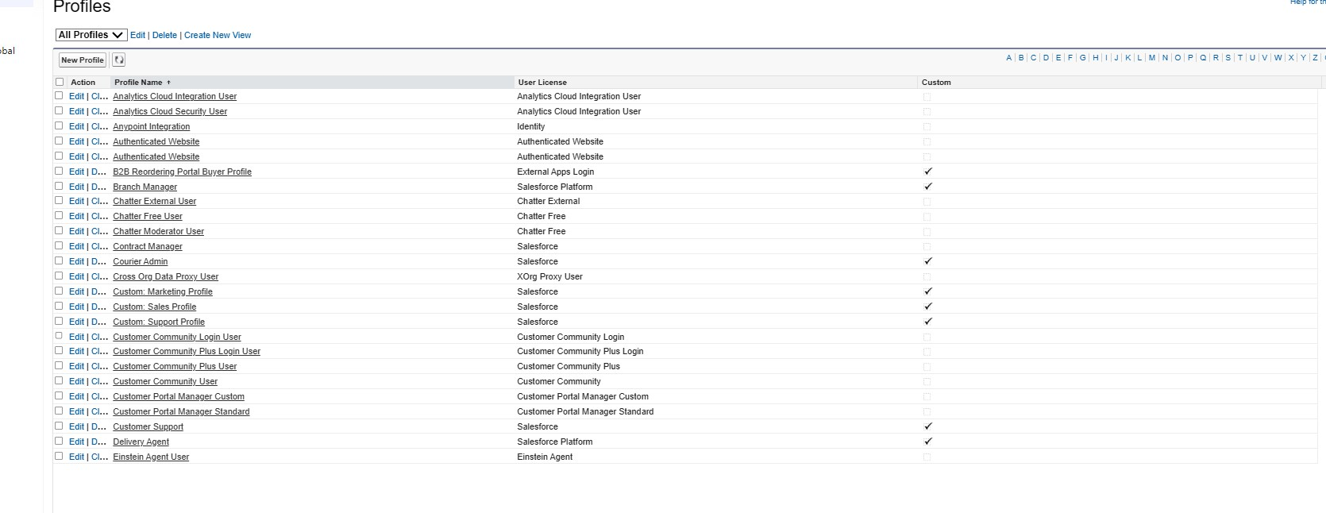

10. ROLES & 11. USERS
Role Definition
Roles are used to determine data access and define the reporting hierarchy within the Salesforce organization.

Activity: Create Role Hierarchy
- From Setup, search for Roles.
- Open Set Up Roles.
- Click Expand All.
- Add Role under CEO and label it Courier Admin.
- Save.
- Below Courier Admin, click Add Role.
- Enter Branch Manager and save.
- Below Branch Manager, click Add Role.
- Enter Delivery Agent and save.
- Under Branch Manager, click Add Role.
- Enter Customer Support and save.
User Definition
A user is a person who logs in to Salesforce. The user account is configured with a role, user license and profile.

Activity: Create User
- Setup → Users → Users.
- Click New User.
- Enter the required name fields.
- Enter a unique username.
- Enter the email.
- Select the role.
- Select the user license.
- Select the profile.
- Click Save.
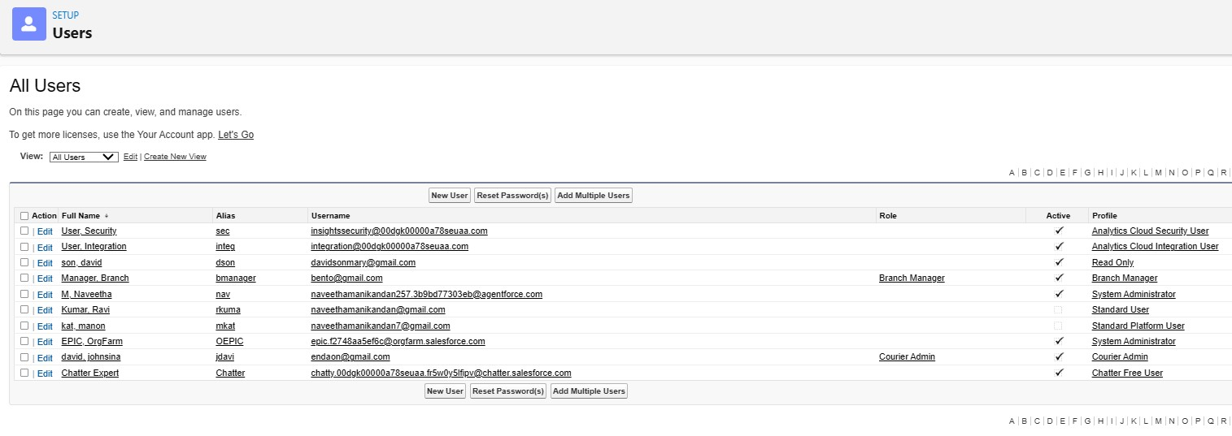

12. REPORTS & DASHBOARDS

Definition
Reports organize Salesforce records into summaries. Dashboards display report results as charts, tables and metrics.

Activity 1: Create a Report
- Open Reports.
- Click New Report.
- Select the required report type.
- Click Start Report.
- Add the required filters and columns.
- Group records when required.
- Save the report.

Project Reports
- Shipment Status Summary – Tracking Number, Customer, Status, Expected Date, Assigned Agent; group by Status.
- Agent Performance – Agent Name, Branch, Number of Shipments, Status; group by Delivery Agent.
- Revenue by Branch – Tracking Number, Customer, Price, Invoice Status; group by Branch and Month.

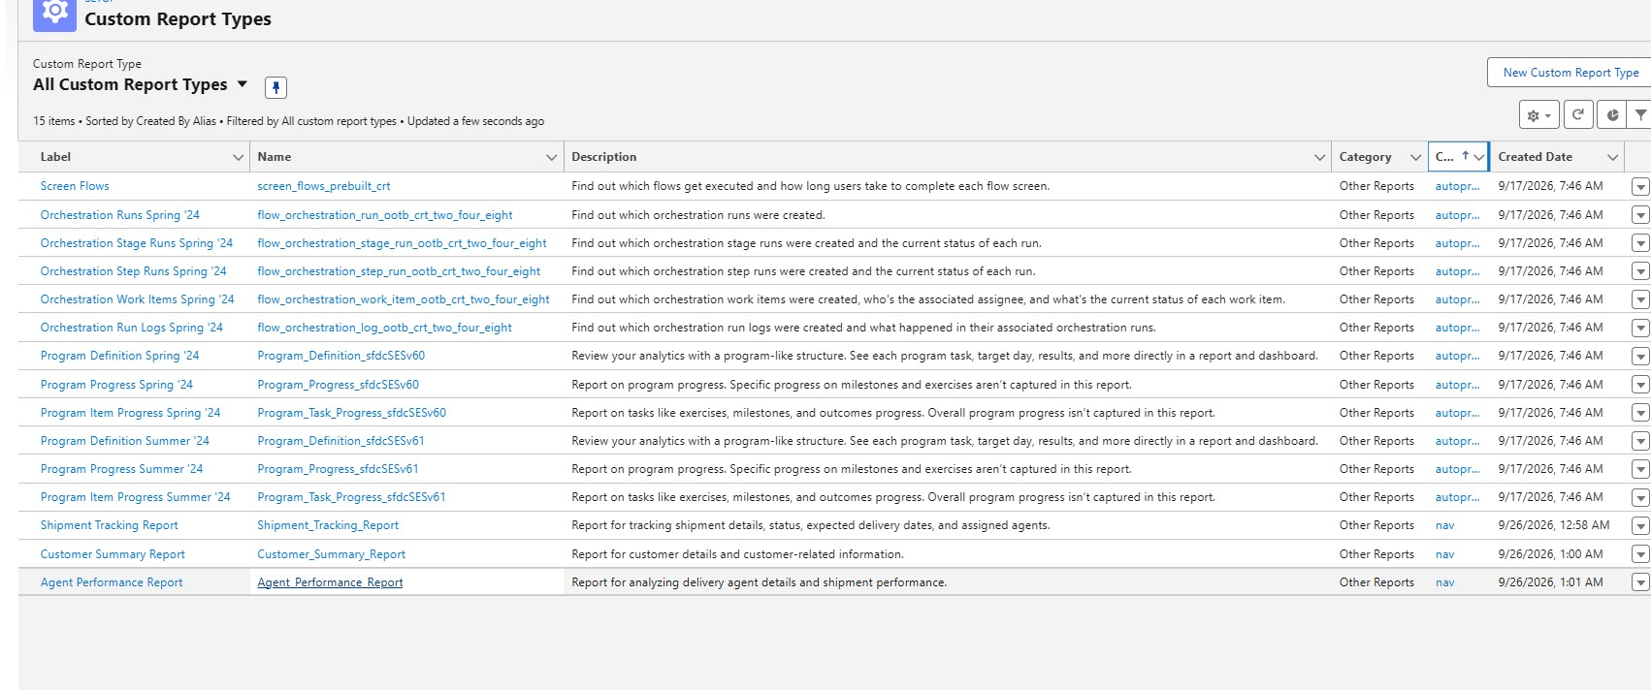

Activity 2: Create Dashboard
- Open Dashboards.
- Click New Dashboard.
- Enter dashboard name: Courier Management Dashboard.
- Select the required folder, such as CMS Reports.
- Click Create.
- Add components from the project reports.
- Use Donut for Shipment Status Overview.
- Use Bar for Agent Performance.
- Use Column for Revenue by Branch.
- Save and share with the required project users/groups.

